SmartPlant 3D Electrical v7
User Training Exercises

Table of contents
Table of contents ii
LAB-1: Routing Cableway-Pinpoint 1
LAB-2: Routing Cableway - SmartSketch 6
LAB-3: Routing Cableway from End Features 8
LAB-4: Routing Cableway from Electrical Equipment Port 10
LAB-5: Connecting Cableways 11
LAB-6: Relative Tracking 14
LAB-7: Spherical Coordinates 16
LAB-8: Cableway – Size Change 18
LAB-9: Branching Out 19
LAB-10: Insert Component 20
LAB-11: Cableway No Part Spec 27
LAB-12: Cableway Editing 30
LAB-13: Setting Default Properties 35
LAB-14: Multi Tray Routing 37
LAB-15: Stacked Tray Routing 42
LAB-16: Stacked Tray Advance Routing 45
LAB-17: Stacked Tray Advanced Routing (Optional) 51
LAB-18: Connecting Cableways (Optional) 53
LAB-19: Electrical Equipment Placement 54
LAB-20: Electrical Equipment Placement with Relationship 57
LAB-21: Conduit Routing 59
LAB-22: Additional Conduit Routing (Optional) 63
LAB-23: Branching from Elbows Using Blank Spec 65
LAB-24: Miter Turns 67
LAB-25: Cableway Splits 68
LAB-26: Routing Cable 70
LAB-27: Routing Parallel Cables 72
LAB-28: Defining Cable Path (Manual) 74
LAB-29: Defining Cable Path (Auto Route) 76
LAB-30: Duct Banks 77
LAB-31: Modify Routing 79
LAB-32: Hangers 80

LAB-1: Routing Cableway-Pinpoint

- Open a Session file with Imperial Units
Note: Session file stores settings from the last time you were in SmartPlant 3D. The name of the current session file appears in the title bar of the application, along with the name of the task, model and filter. One of the settings saved in the session file is the workspace. See the Common Applications labs on how to define a workspace
- Define Workspace to Display U04 and U04 CS
- If you are not in the Electrical task, then select Tasks > Electrical
- Make sure permission group is set to Electrical
Note: Objects that you place directly in the model are assigned to the active permission group. Therefore, you are responsible of making sure the objects are assigned to the appropriate Permission Group

- In Pinpoint set Active Coordinate system to U04 CS
- Select set target to origin option to move the target to U04’s origin
- Select Route Cableway command on the vertical toolbar
- Key in 5’ for E, 30’ for N and 26’ for EL and Left click in the view
- The system opens the Create Cableway Dialog box. Select “More…” option in the System property field to open the Select System dialog box. Select U04, Electrical, Control, CT system and Click OK
- On the Create Cableway dialog box. Select the cableway specification CB-S1-L6-12B
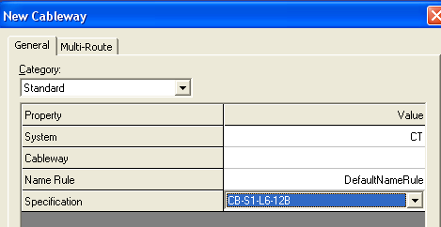
- Switch the Category to Cable fill and set the following values:
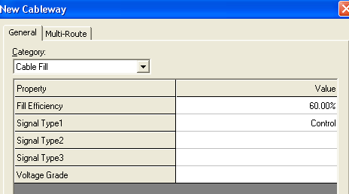
- Click OK to close the Create Cableway dialog
- Under Offset, select set offset reference
- Select Cardinal Point Option
- Select Bottom Center and OK on the form

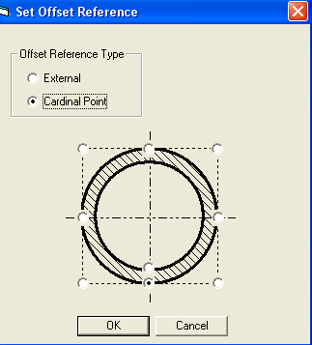

- Verify Rectangle under Shape and Key in 2’ for Width and 4” for the depth
- Go to the Route ribbon bar (click in Length field or use Alt+G) and key in 8’ in the box.
- Go to the Route ribbon bar and set the working plane to PLAN.
- Position the cursor in the Easting direction (“E” glyph should appear).

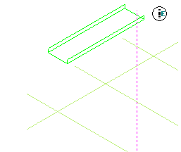

- Left mouse click to accept the endpoint.
- Go to the Route ribbon bar and key in 12’ in the length box.

- Position the cursor in the Northing direction.

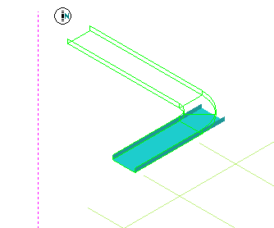

- Left mouse click to accept the next endpoint
- Go to the Route ribbon bar and key in 6’ in the length box.

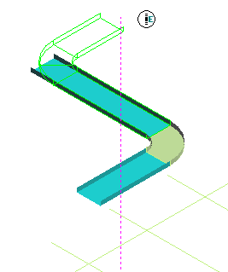

- Position the cursor in the Easting direction
- Left mouse click to accept the next endpoint
- Right mouse click to terminate the Route cableway command.
- Finished Run should resemble this:

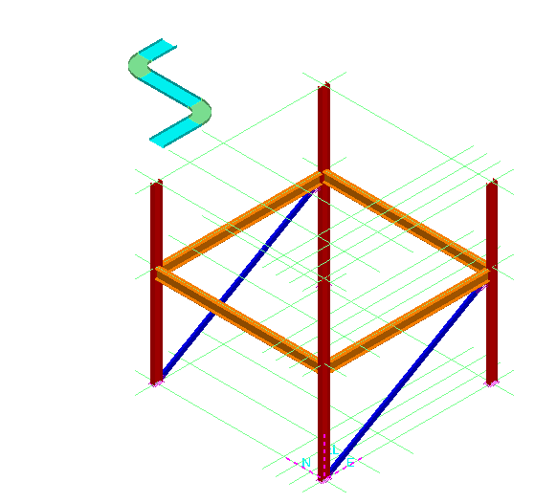

- Select Route Cableway command on the vertical toolbar
- Make sure Active CS is U04 CS
- Key in 30’ for E, 50’ for N and 26’ for EL as starting point
- Keep all the defaults on New Cableway Form (same as previous lab)
- Make sure the tray Width is 2’ and Depth is 4”
- Route the shown Cabletray Run
10’ East 10’ Up 5’ East 5’ North
12’ East 10’ South 8’ 6” Down 5’ South

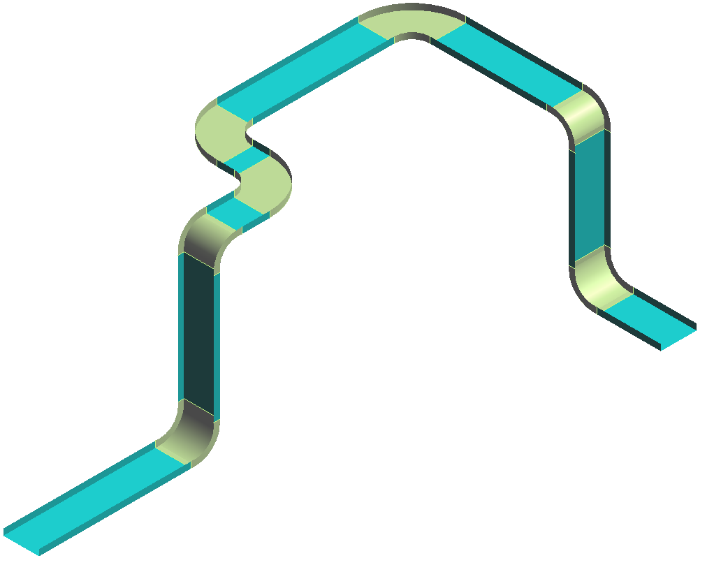

LAB-2: Routing Cableway - SmartSketch

- Open a Session file with Imperial Units
- Define Workspace to Display U04 and U04 CS
- If you are not in the Electrical task, then select Tasks -> Electrical
- Set Active Coordinate system to U04 CS
- Select set target to origin option
- Re-Position Target to grid intersection shown below
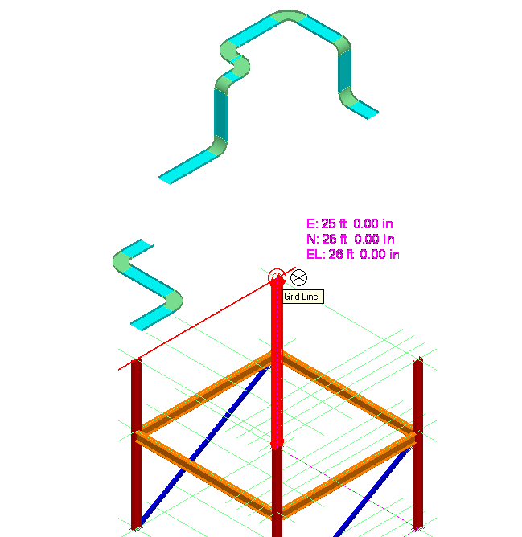

- Select Route Cableway command on the vertical toolbar
- Start new cableway, 3’ North of above intersection (Key in 0’ fro East, 3’ for North and 0’ for EL)
- Keep same defaults as previous lab on New cableway form
- Change the width to 1’ 6” and depth to 4”

- Route 10’ East and Go South until you are aligned with First E/W grid plane as shown. Left click to place the tray and right click to terminate the command
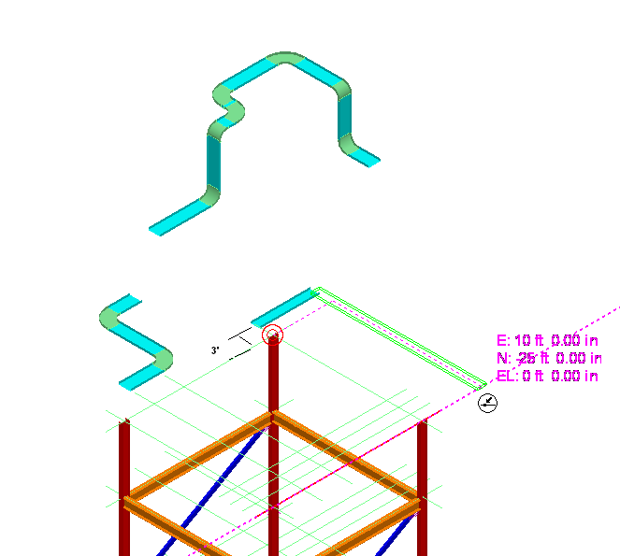
.

LAB-3: Routing Cableway from End Features

- Open a Session file with Imperial Units
- Define Workspace to Display U04 and U04 CS
- If you are not in the Electrical task, then select Tasks -> Electrical
- Set Active Coordinate system to U04 CS
- Select set target to origin option
- Click Route Cableway command on the vertical toolbar.
- Select the N-E end of Tray placed in Part I
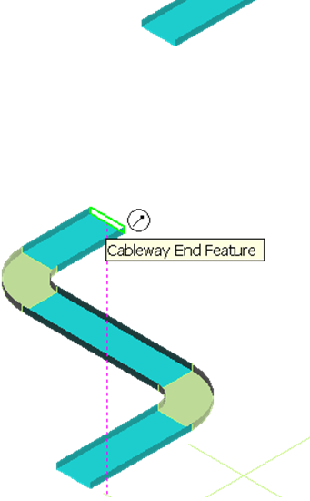

- Set the Plane to Plan.
- Move Cursor toward North and Middle Mouse Click to lock in N-S direction
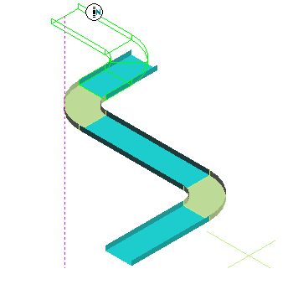

10 With N-S direction locked, move the cursor over West-East Run of second tray, until the intersecting lines show up. Left click to place the tray.

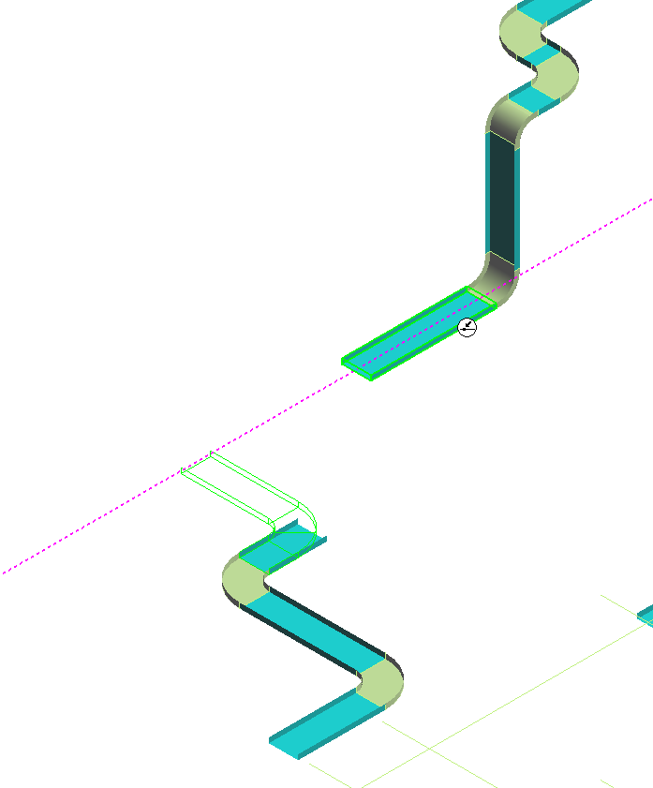

11 Right click to finish the run

LAB-4: Routing Cableway from Electrical Equipment Port
- Set the Workspace to U01 and select Place Equipment command. Select Electrical > Electrical Enclosures > Electrical Enclosure > BA106E 42369-1-E.
- Name it EBOX-001
- Place it in system A2 > U01 > Electrical > Low Voltage.
- Place it at E 27’, N 7, EL 4 in Unit 1 (U01) coordinate system.
- Click Route Cableway command on the vertical toolbar.
- Select the Tray nozzle port of Ebox-001 as the starting point.
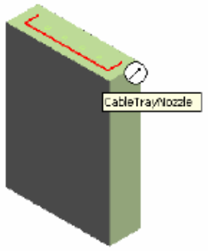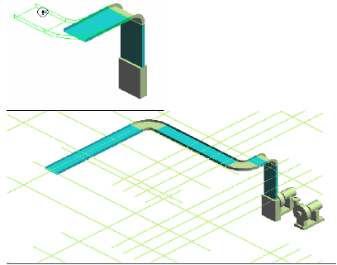
- Place trays in system A2 > U01 > Electrical > Low Voltage > CT
- Change the Spec to CB-S1-L12-12B. Fill Efficiency to 75 and OK.
- Move the cursor over the U-shaped connection port until it highlights as shown in the illustration above. While the port is highlighted (don’t click the mouse), press function keys F6 and F7 to lock Easting and Northing coordinates.
- Press F8 and enter Elevation 15’ when the field highlights. The end of the cable tray will appear at that elevation when the cursor is moved in the graphics window.
- Use the Function keys to lock the current Elevation (F8) and Northing (F7) coordinates, then press F6 to lock the Easting direction, place the cursor at the end of East key-in field value and enter -5. This will subtract 5ft from the displayed value.
- Route to coordinate N 25’.
- Route to coordinate E -5’.

LAB-5: Connecting Cableways

- Open a Session file with Imperial Units
- Define Workspace to Display U04 and U04 CS
- If you are not in the Electrical task, then select Task -> Electrical
- Set Active Coordinate system to U04 CS
- Select set target to origin option
- Click Route Cableway command on the vertical toolbar.
- From Ribbon Bar Disable the offset (Disable the Cardinal Point routing).
- Join the two trays by Starting From the West end of Second Tray and connecting to the North end of First tray.
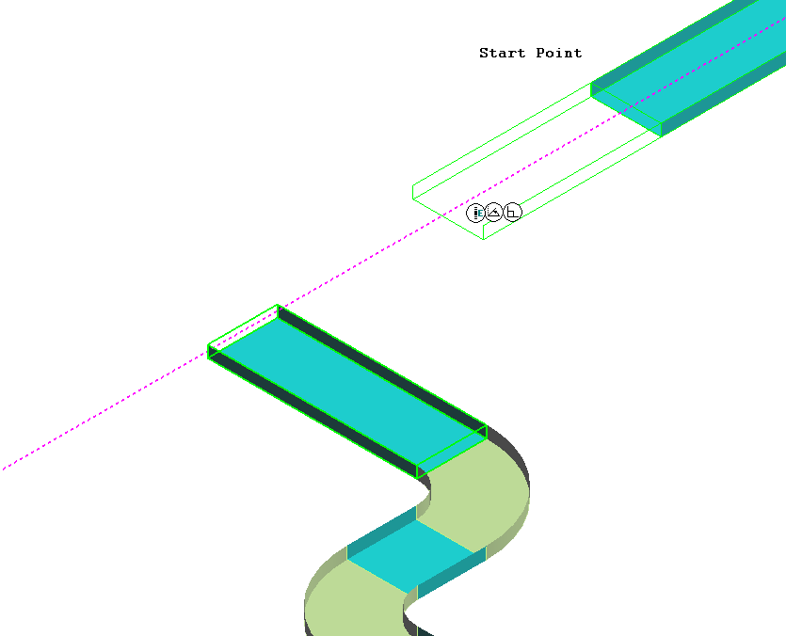

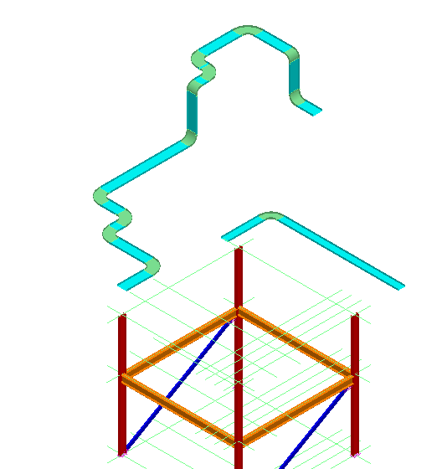

- Select Route Cableway command
- Start at the West end of 18” x 4” Tray as shown
- Connect to the East West run tray as shown
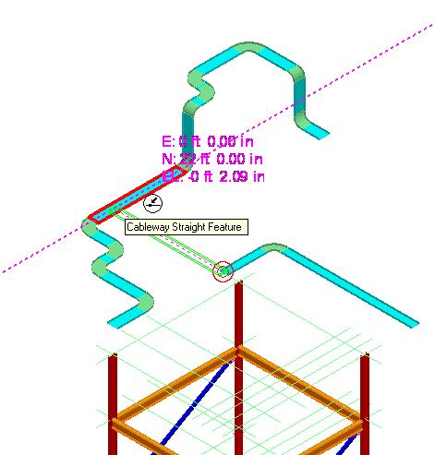

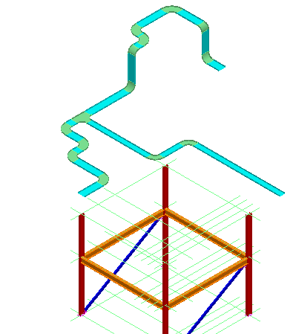

Note: If the Tee does not appear, verify that you are using spec CB-S1-L6-12B. A spec with an S2 in the name will not have tees loaded in the catalog

LAB-6: Relative Tracking

- Open a Session file with Imperial Units
- Define Workspace to Display U04 and U04 CS
- If you are not in the Electrical task, then select Task -> Electrical
- Set Active Coordinate system to U04 CS
- Enable the relative tracking option.
- Click Route Cableway command on the vertical toolbar.
- Select the end feature at South end of the Tray (see figure) as starting point

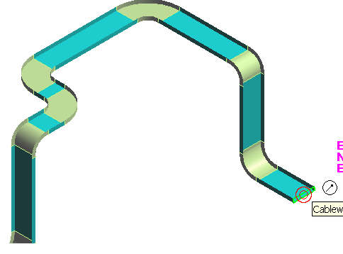
- Key in East 10’, North -10’ and El 0’
- System will show the new dynamics. Left click to place the run.
- Then place another run due East 15’ long.

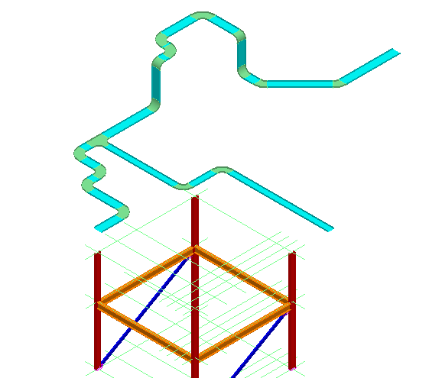

LAB-7: Spherical Coordinates

- Open a Session file with Imperial Units
- Define Workspace to Display U04 and U04 CS
- If you are not in the Electrical task, then select Task -> Electrical
- Set the Pin Point readouts to spherical coordinate system.
- Re-position Target to East end of Tray routed in above lab
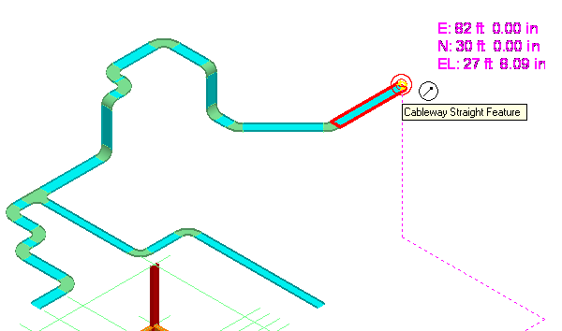
- Click Route Cableway command on the vertical toolbar.
- Select the East end of Tray placed in previous lab(shown above)
- Go to the Pin Point ribbon bar and lock the Distance, Horizontal and Vertical directions as follows:
Absolute Distance: 10’
Horizontal (N>CW): NE 45.00 Deg
Vertical(Plan>CCW): Flat with Plan 0.00
- System Shows the dynamics of new Tray at 45 degree from North
- Left click to place the tray
- Place another Tray East 5’

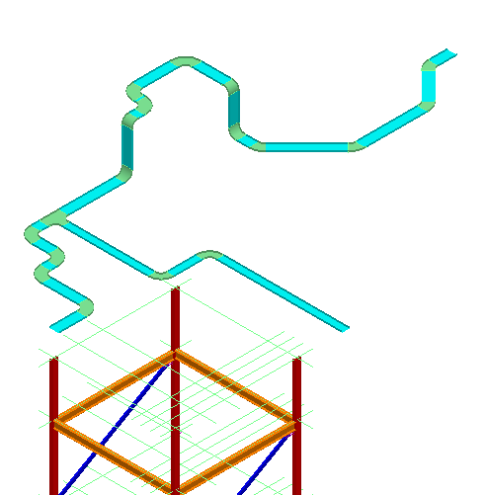

LAB-8: Cableway – Size Change

- Open a Session file with Imperial Units
- Define Workspace to Display U04 and U04 CS
- Click Route Cableway command on the vertical toolbar
- Select the East most end of Tray
- Change the size to 18” X 4”
- Route East 5’
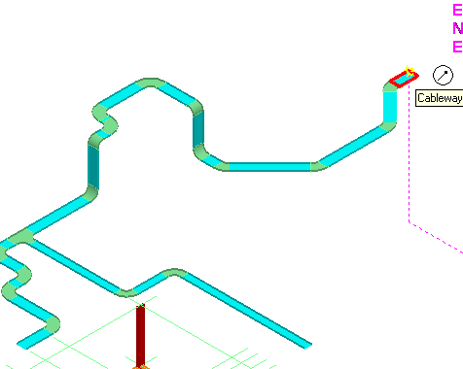

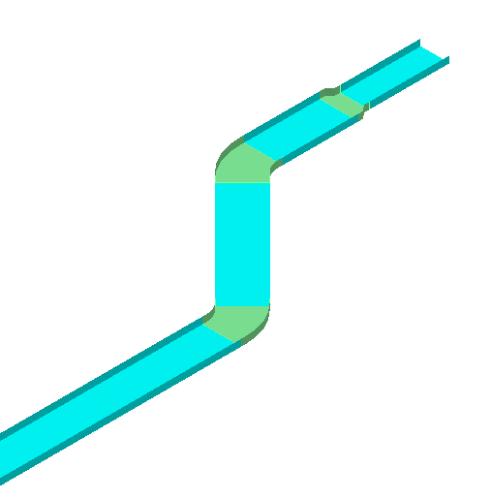

LAB-9: Branching Out

- Open a Session file with Imperial Units
- Define Workspace to Display U04 and U04 CS
- Select Reposition Target (F12).
- Place target at the South End Feature as shown

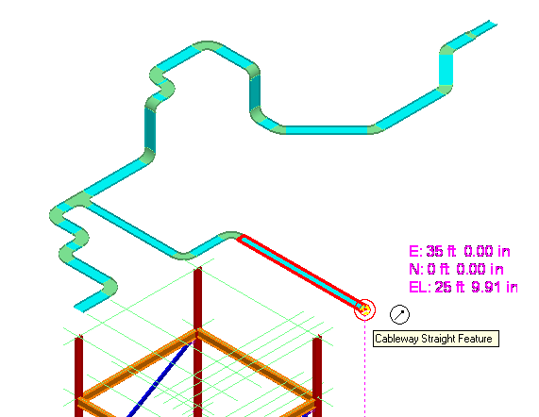

- Select Route Cableway command on the vertical toolbar
- Key in 10’ for North select the Straight Feature
- Route East 10’
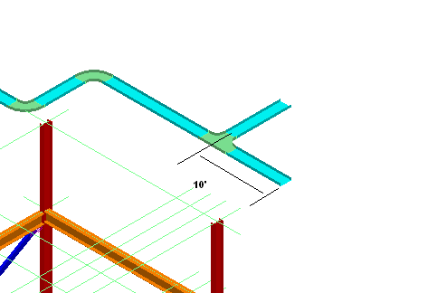

LAB-10: Insert Component

- Open a Session file with Imperial Units
- Define Workspace to Display U04 and U04 CS
- Select insert component command
- Select the end feature as shown

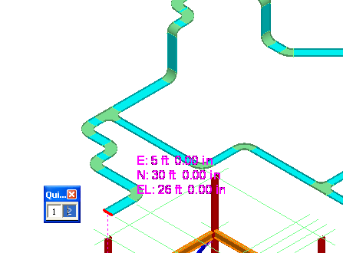

- Select more under part list
- Expand the Catalog Browser and find Cable Tray Parts\Cable Tray Tee\CT Horizontal Tee\Cable Tray Reducing Tee
- Select Horizontal Reducing Tee, from 2’ X 4” to 1’ X 6”, Bend Radius 2’. Part Number 4P-24-18HT12 (click Part Number heading to sort by part number)
Part Number: Once you understand how parts are numbered, selection becomes very easy. Lets explore part number 4P-24-18HT12, in this: 4P is Series, 24 the main size, 18 is reducing size, HT for Horizontal Tee and 12 is turning radius.
- Select the part and OK on the Catalog browser
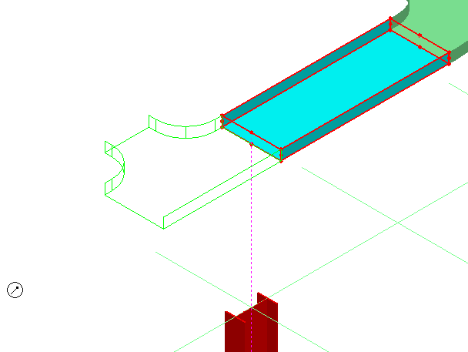

- Select Finish.
- Select More… from the Part field
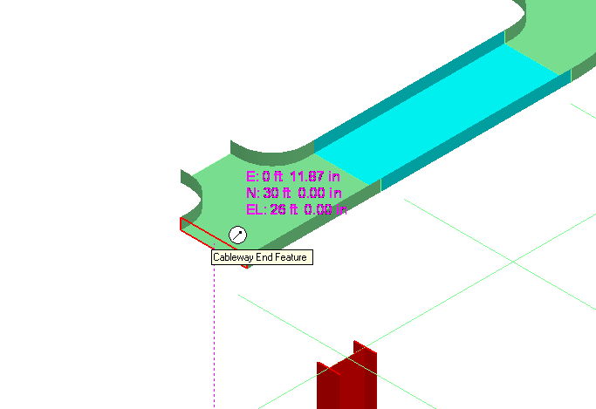

13 From Catalog select Cable Tray Bend, CT Vertical Bend, and then select 2’ X 4”, 45 degree Outside Vertical
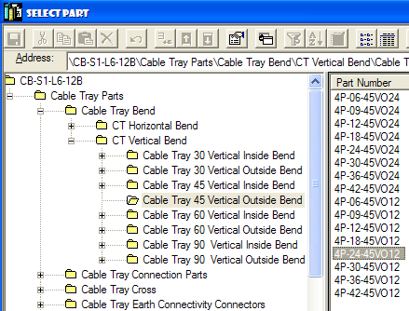

- Select Finish
- Select more… and place an Inside vertical bend 45 as shown(4P-24-45VI12)

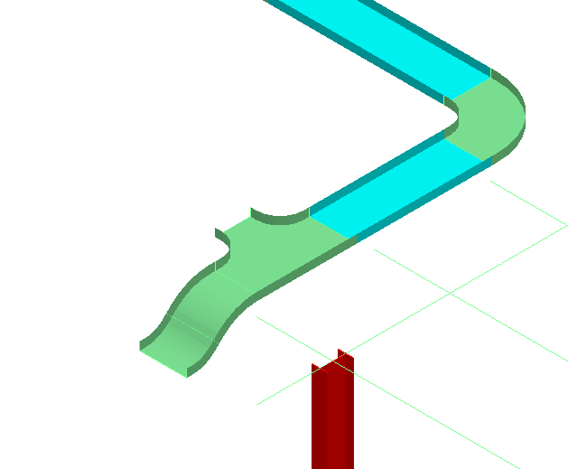

- Select Finish
- Use the Route Cableway command to route West 5’ from the fitting as shown
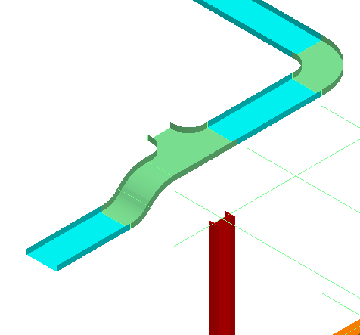

- Place a TEE, and route tray as shown in the picture below
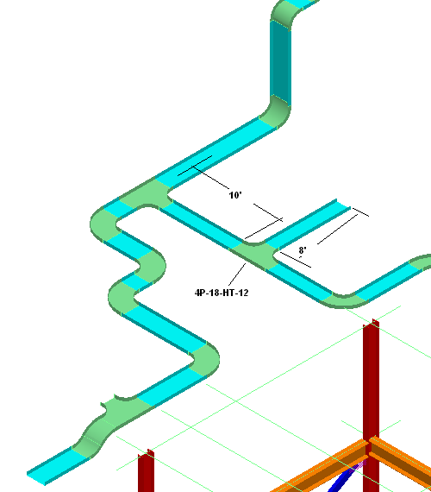

- Select Insert Component on the vertical tool ribbon.
- Activate Point Along command (1 in the picture below)
- Select Reference Option (2 in picture).
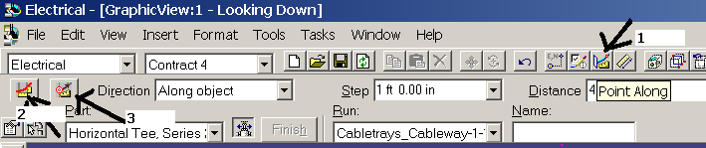
- Select the Straight feature as shown
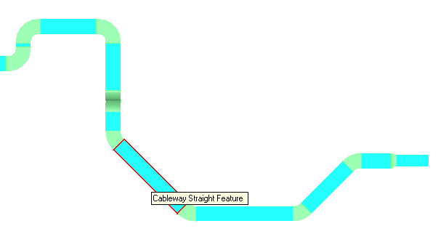
- Select the End Feature at the top end as Reference Point. To redefine the reference, you could select the Reference Point button (3 in picture above) and click on a new reference position
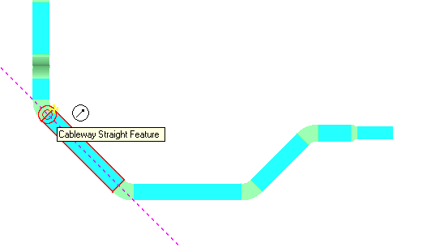
- Select Insert Component command
- Select same straight feature
- Select 24”, Horizontal Tee, Radius 12” from catalog
- Key in 5’ for distance
.
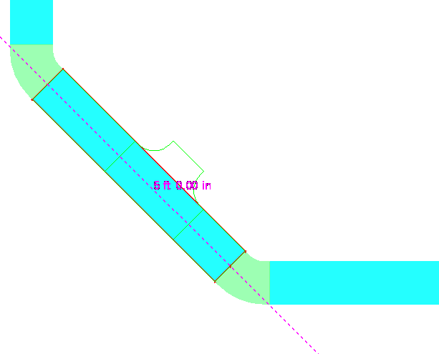

- Left click to accept the position
- Set Reference Position to Port 1
- Finish to place the TEE

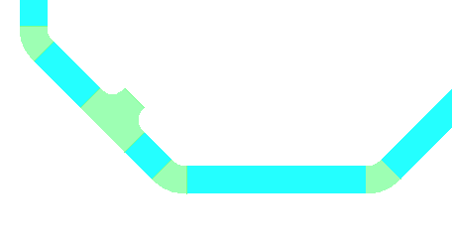

LAB-11: Cableway No Part Spec

- Open a Session file with Imperial Units
- Define Workspace to Display U04 and U04 CS
- Select Route Cableway command on the vertical toolbar
- Select New Cableway option under Run
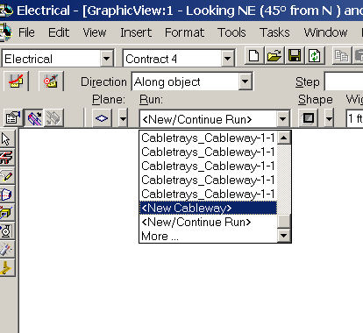

- On new Cableway form, change the Spec to Cws0 . Ok on the form
- Select the end feature shown as starting point. Change the Size to 2’ X 4”
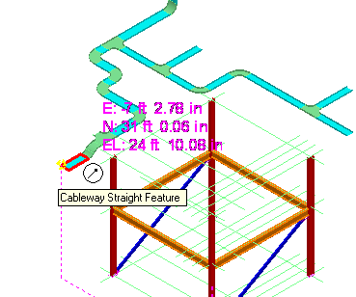
- Route West 5’
- Select insert transition command from Vertical tool bar.
- Select 3’ for Width, 2’ for Depth and 4’ for Length.

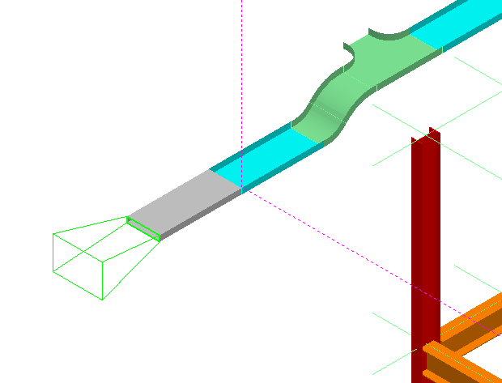

- Select Finish.
- Route from transition feature, 10’ west, then 15’ South
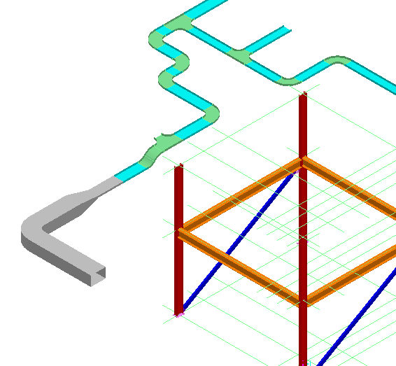

- Select insert transition command
- Change the Width to 18” , Depth to 1’ and the length to 2’
- Select Align Bottom left option under Align (first row last button)
- Select Finish
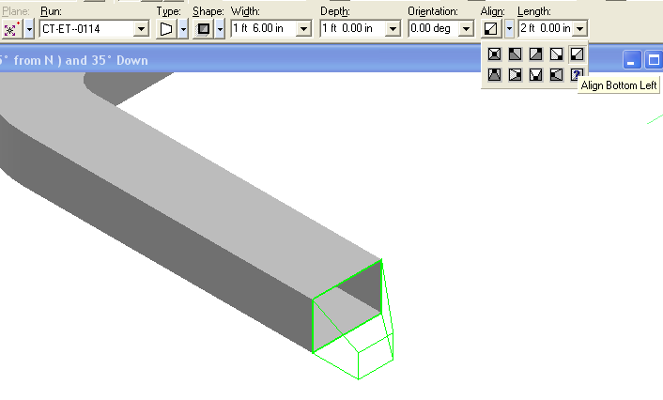

18 Route 10’ South from the transition

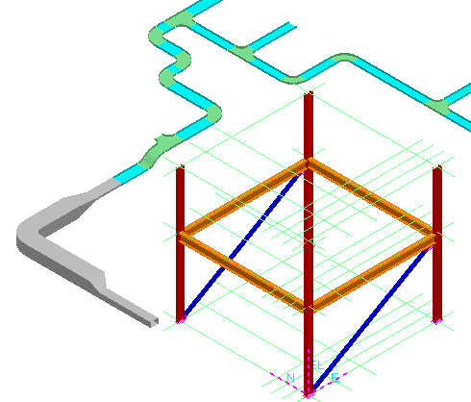

LAB-12: Cableway Editing

- Open a Session file with Imperial Units
- Define Workspace to Display U04 and U04 CS
- Activate Pin Point Ribbon Bar
- Change the locate filter to Cableway Features
- Activate Relative Tracking
- Select the Straight Feature Shown below
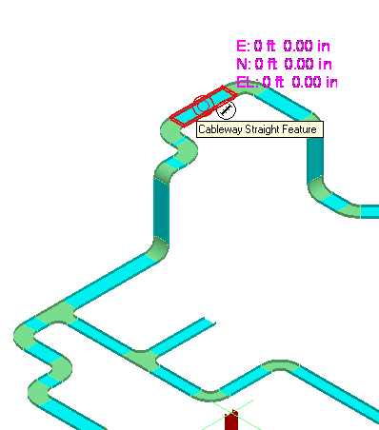
- Select Move To option
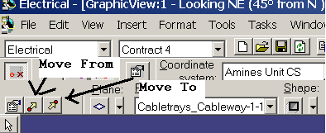
- Key in 5’ North
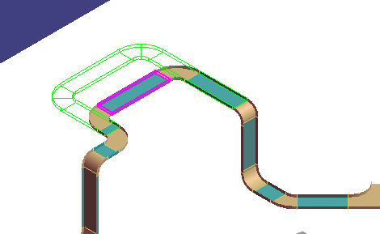

- Left click to Accept the move. Right click to cancel the command
- Select Point Along option
- Define the SF shown as Reference object
- Define the point shown as Reference point
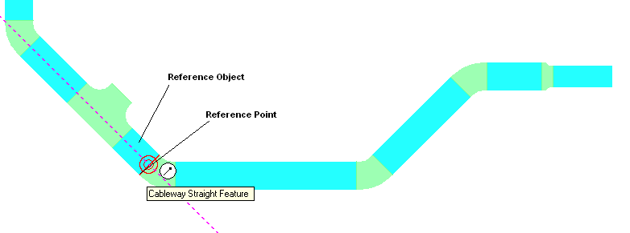
- Select the Straight Feature at the end, while holding shift key select the Turn Feature as shown
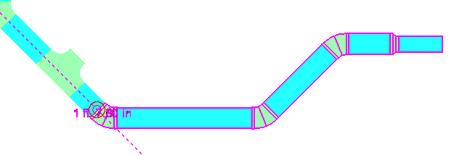

- Select the Common Move command
- Check the fast move option (a fence appears instead of wireframe tray)
- Select top End Feature of Elbow as From point
- Key in 5’ for distance
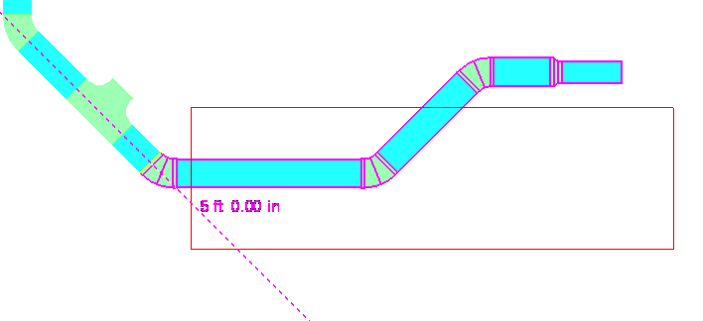
- Left click to Accept new location

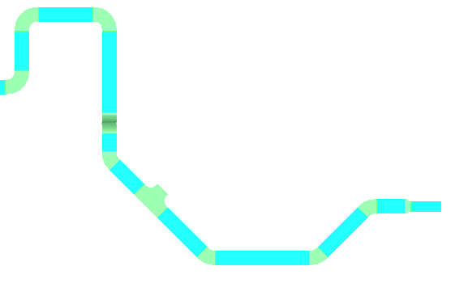

- Move the Tee Next to Elbow as shown below
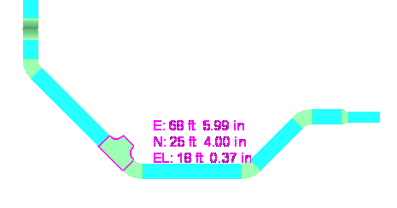
- Using move command, move the Elbow so it changes to 90 degree, and 45 degree elbow next to Tee disappears
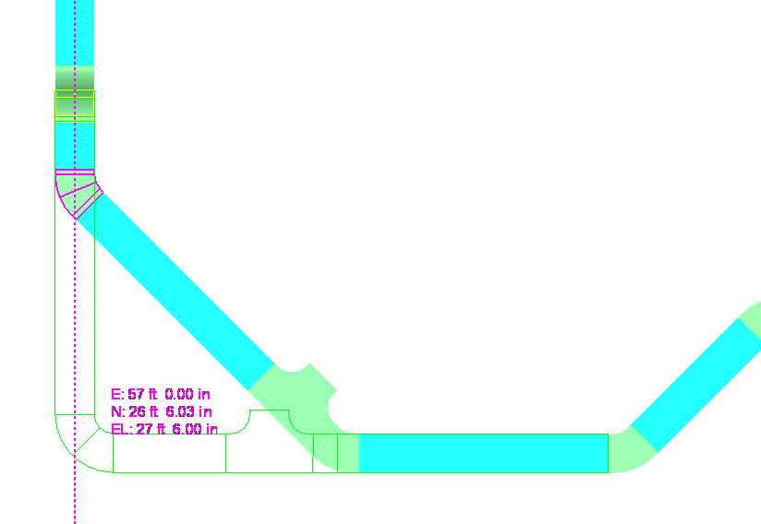
- This can be done by dragging the elbow South using Move To until it lines up with horizontal run, or changing the fitting angle to 90 degree, and locking the other 90 angle in the ribbon bar

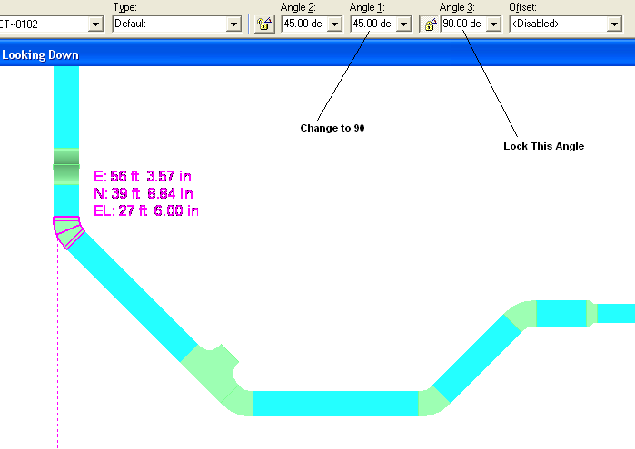

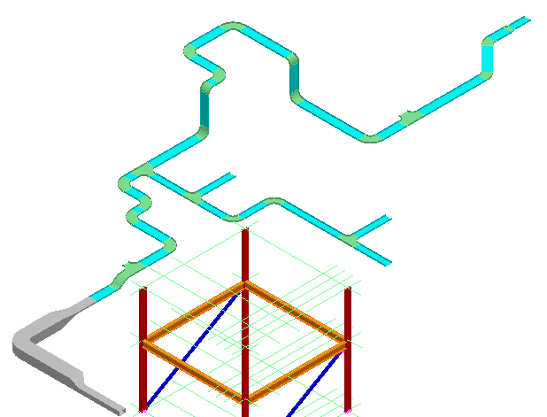

LAB-13: Setting Default Properties

- Open a Session file with Imperial Units
- Define Workspace to Display U03 and U03 CS
- Activate Pin Point Ribbon Bar
- Change the locate filter to All
- Expand Workspace explorer and highlight CT under, A2 > U03>Electrical>Control
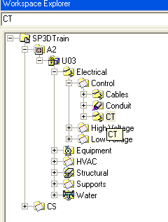
- Open properties page for This system (right click > properties)
- From System Properties options, select Default Properties Values tab
- Under Standard category, Select Specification to CB-S1-L6-12B
- Change the Category to Cable Fill
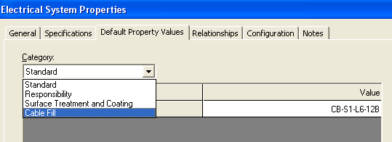

- Define following Values
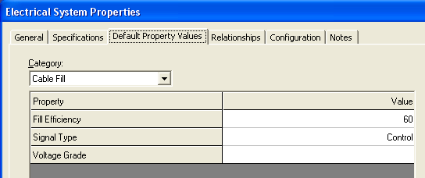

Note: If you want to use cable Auto route functionality (to be introduced later), you must define these 2 attributes
- OK on the form
- Expand Workspace explorer and select CT under, A2 >U03>Electrical>Low Voltage
- Open properties page for This system (right click > properties)
- From System Properties options, Switch to Default Properties Values tab
- Under Standard category, Select Specification to CB-S1-L6-12B
- Change the Category to Cable Fill
- Define fill Efficiency at 60%, and Signal type to Power
- OK on the form
- Save session file

LAB-14: Multi Tray Routing

- Open a Session file with Imperial Units
- Define Workspace to Display U03 and U03 CS
- Activate Pin Point Ribbon Bar
- Change Active CS to U03 CS
- Set target to origin option
- Select Place Equipment command from the vertical toolbar to open the select Equipment Dialog box.
- Locate the electrical enclosures part number BA-106E42309-1E using the tree view. Select the part and click the OK button.
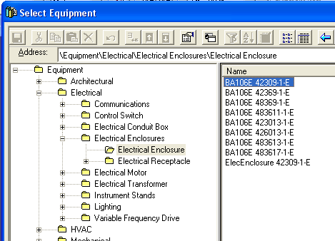
- Name the equipment, E-100A
- Change the System to A2>U03-> Equipment System
- Switch to Position and orientation category, make the following changes and OK:
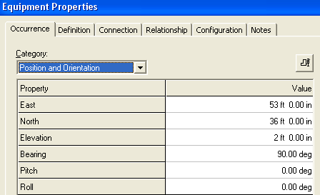
- Select place equipment command again
- Select same part as above
- Name the equipment, E-100B
- Change the System to A2>U03-> Equipment System
- Switch to Position and orientation category, and make following changes:
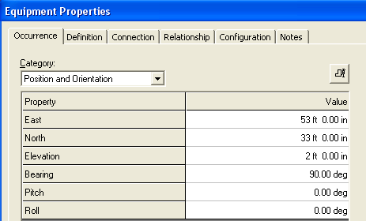

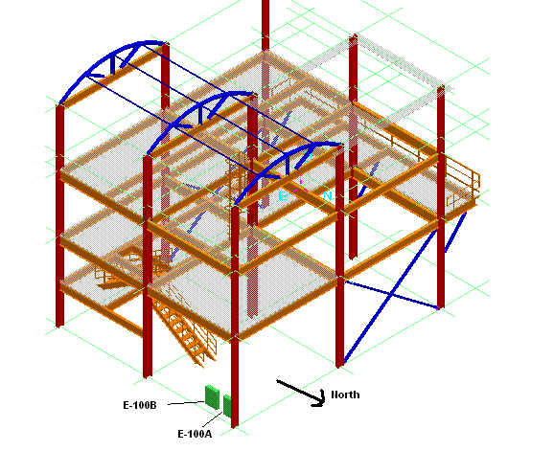

- Select Route Cableway command
- For Starting location, Key in East 53’ 2”, North 37’ 2” and EL 6’
- Click in the view
- On the New cableway select A2, U03, Electrical, Control, CT for system
Note: If you get a warning about systems, select the new system to inherit properties from parent system
- Software should update the Spec info based upon the default Parent system settings
- Switch to Cable fill category, verify the information is correct
- Switch to Multi Route Tab
- Make the following changes
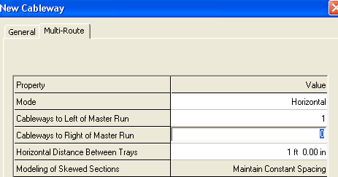
- Ok on the form
- Select 2’ for Width and 4” for depth
- Route the shown cabletrays. Refer to pictures for details
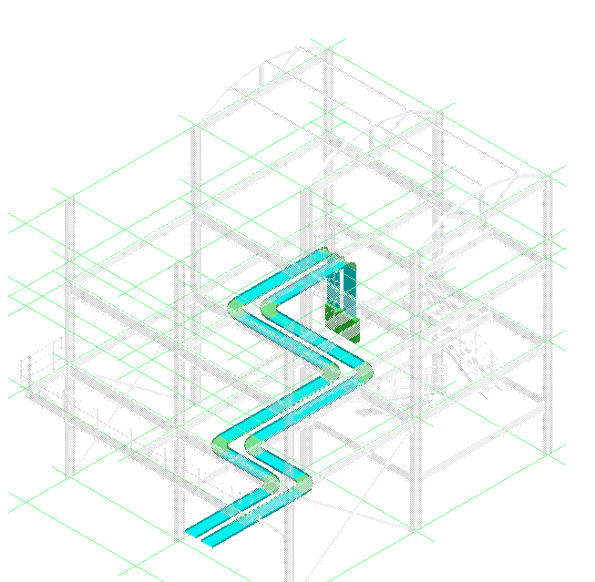

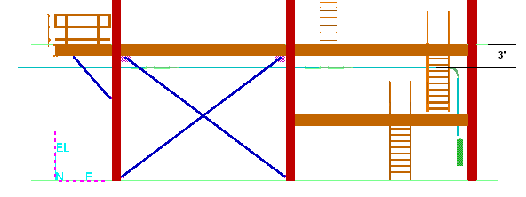

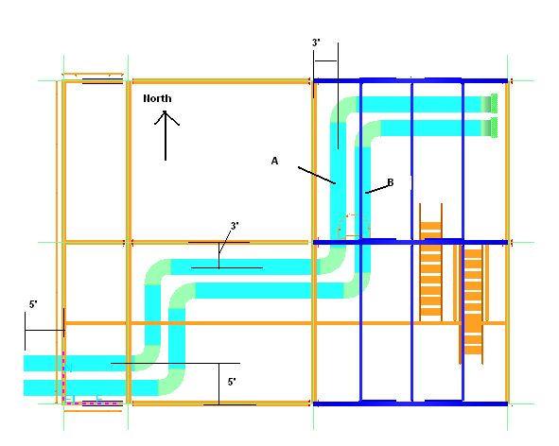

- Set locate filter to Cableways
- Select the Cableway Marked B, in above picture
- Open its property page, Change the system to A2, U03, Electrical, Low Voltage, CT. Switch to Cable Fill category. Change the signal type to Power

LAB-15: Stacked Tray Routing

- Open a Session file with Imperial Units
- Define Workspace to Display U02 and U02 CS
- Activate Pin Point Ribbon Bar
- Change Active CS to U02 CS
- Set target to origin option
- Set locate filter to All
- Select CT system, under A2, U02, Electrical, Control
- Set the default Spec to CB-S1-L6-12B
- Set Cable fill to 60% and Signal Type to Control
- Select CT system, under A2, U02, Electrical, Low Voltage
- Set the default Spec to CB-S1-L6-12B
- Set Cable fill to 60% and Signal Type to Power
- Select Route Cableway command
- For Starting location, Key in East 43’, North 1’ 8”, and EL 15’ 6”
- Click in the view
- On the New cableway select A2, U02, Electrical, Control, CT for system
Note: If you get a warning about systems, select the new system to inherit properties from parent system
- Software should update the Spec info based upon the default Parent system settings
- Switch to Cable fill category, verify the information is correct
- Switch to Multi Route Tab
- Make following changes
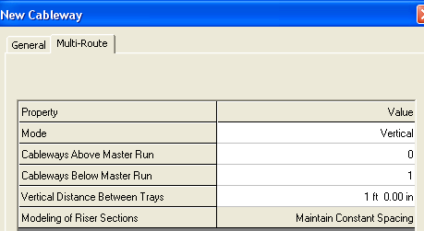
- Change the size to 24” X 4”
- Route the Tray as shown
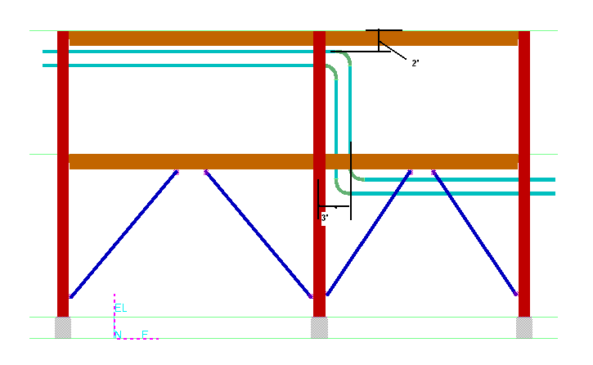
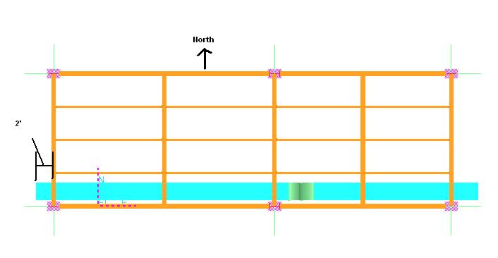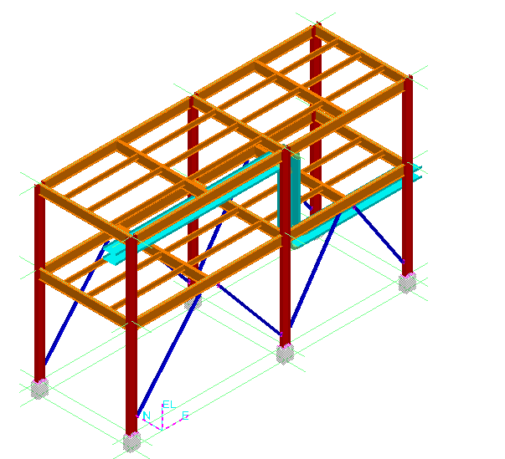
- Set locate filter to Cableways
- Select the Bottom cableway
- Open its property page, Change the system to A2, U02, Electrical, Low Voltage, CT. Switch to Cable Fill category. Verify the signal type is Power

LAB-16: Stacked Tray Advance Routing

- Open a Session file with Imperial Units
- Define Workspace to Display U03 and U03 CS
- Activate Pin Point Ribbon Bar
- Change Active CS to U03 CS
- Set target to origin option
- Set locate filter to All
- Select Route Cableway command
- Key in East -5’, North 1’ 11”, EL 29’
- Click in the view
- On the New Cableway form select A2, U03, Electrical, Control, CT for system
Note: If you get a warning about systems, select the new system to inherit properties from parent system
- Software should update the Spec info based upon the default Parent system settings
- Switch to Cable fill category, verify the information is correct
- Switch to Multi Route Tab
- Make the following changes
- Change the size to 30” X 4”
- Route the Tray as shown
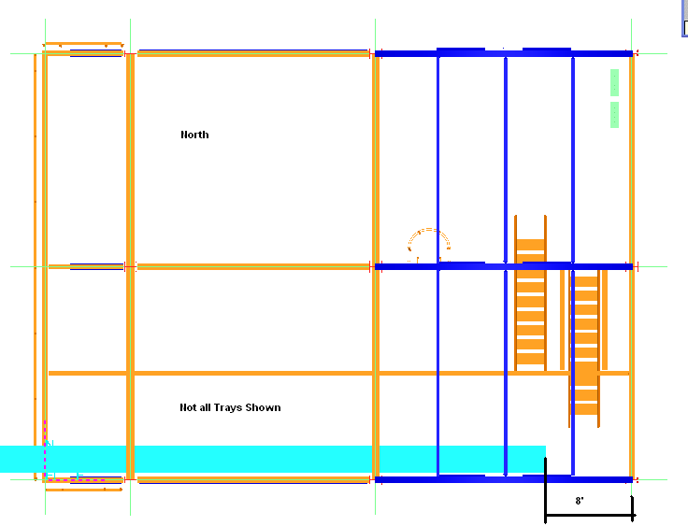
- Set locate filter to Cableways
- Select the Bottom cableway
- Open its property page, Change the system to A2, U03, Electrical, Low Voltage, CT. Switch to Cable Fill category. Change the signal type to Power
- Hide the Bottom(LV) Cableway
- Finish the Control CT as shown in the Picture
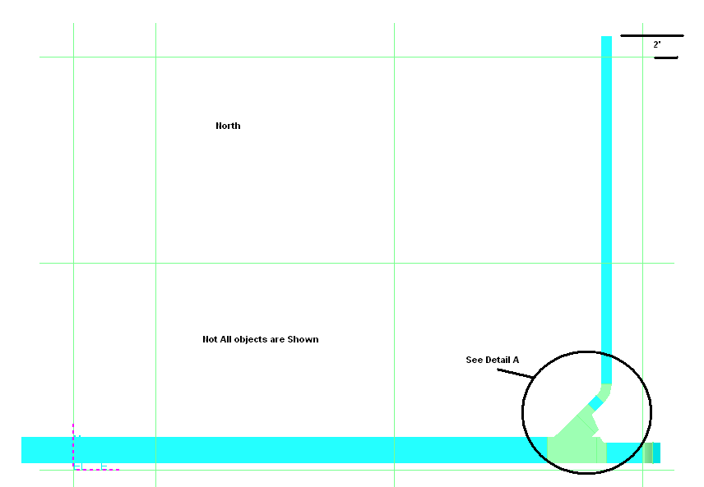

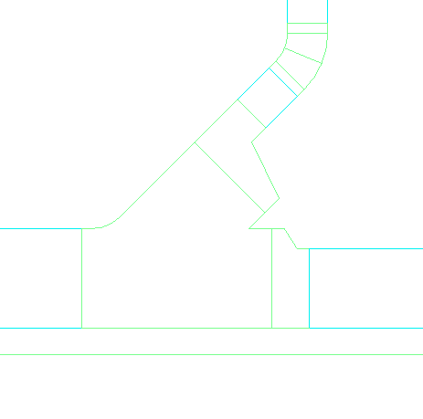
1
2
3
4
Detail A
- Horizontal WYE Left (30” X 4”) – Placed By origin
- Right Reducer (30” x 4” to 24” X 4”)
- Left Reducer( 30”X4” to 12”C4”
- Straight Tray 3’ Length
- Route Straight from 24” Reducer (2 in detail A), to East 55
- Place a 30 degree Outside Vertical Bend as shown
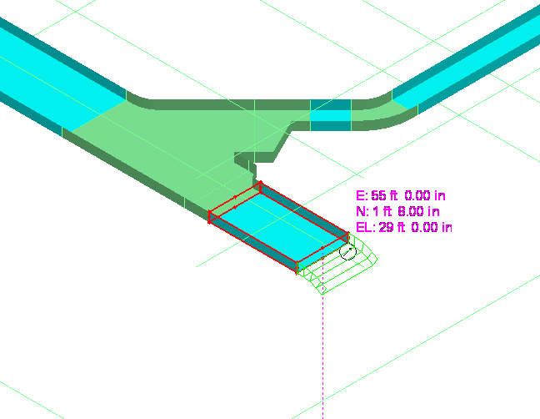
- Set your workspace to display U03 and U02
- Set your locate filter to Cableway Features
- Select the End Feature of Top Tray(control) in U02, and move it back few inches
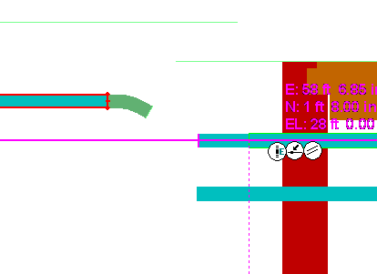
- Start routing from the 30 degree bend, and route to same elevation as the top tray in U02
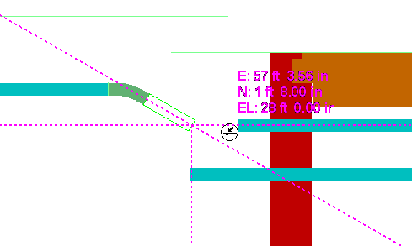
- Start routing at the end of U02 and connect the 2 trays as shown
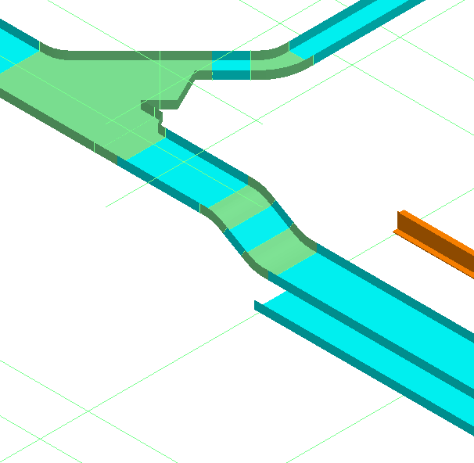

LAB-17: Stacked Tray Advanced Routing (Optional)

- Open a Session file with Imperial Units
- Define Workspace to Display U03 and U03 CS
- Activate Pin Point Ribbon Bar
- Change Active CS to U03 CS
- Set target to origin option
- Set locate filter Cableways
- Hide all Cableways except the Low Voltage on Elevation 27’ 7” as shown
- Select Route Cableway command
- Route as shown in the pictures
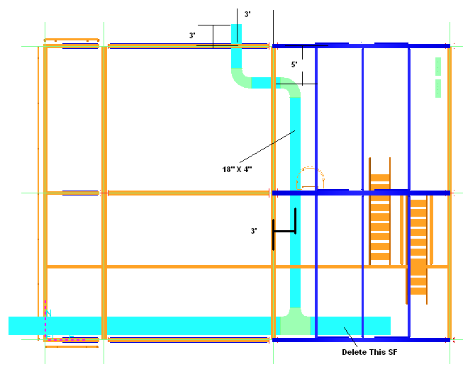
- Set locate filter to Cableway Feature and delete the SF shown marked in above pictures
- Place a 30” X4” to 24” X 4” Right Reduce after TEE
- Connect to the East end of Reducer and continue Routing to East 55’(U03 CS)
- Then using same method as previous lab, place a 30 degree outside bend, connect to the Low Voltage tray in U02 as shown
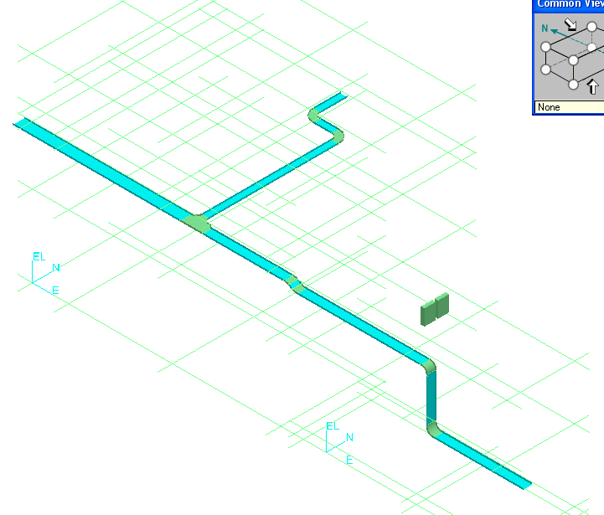

LAB-18: Connecting Cableways (Optional)

- Open a Session file with Imperial Units
- Define Workspace to Display U01 & U02
- Set locate filter Cableway
- Verify that Top Cableway n U01 is Control and Bottom is Low Voltage (if not, switch the systems)
- Connect the Trays from U02 to U01 any way
- Below Picture is just for reference
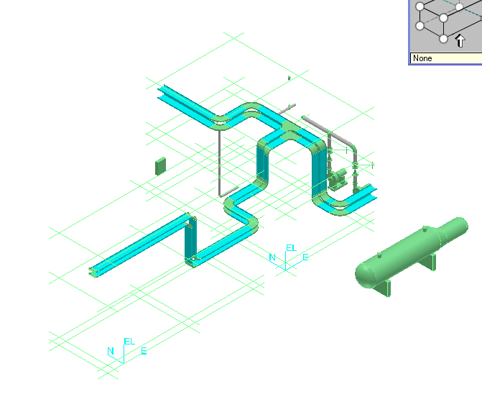

LAB-19: Electrical Equipment Placement

- Open a Session file with Imperial Units
- Define Workspace to Display U03 and U03 CS
- Activate Pinpoint
- Set Active CS to U03 CS
- Select set target to origin option
- Select place equipment command
- Browse to Equipment\Electrical\Lighting\Electrical Light and select ElectricalLight01-E

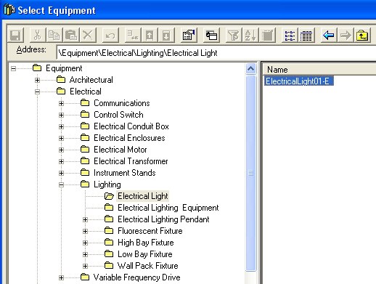

- On properties page, Change the Name to EL-U03-1
- Change the system to A2 > U03 > Equipment
- Switch to Equipment Dimension category
- Change the Equipment Height to 15’
- Switch to Position and Orientation category, and key East 31’, North -1’ EL 0 and change the Bearing to 180
- OK on the form
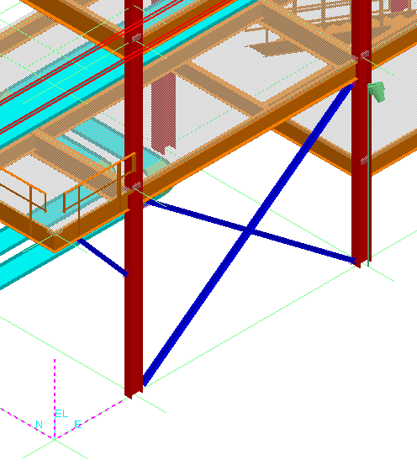
- Select place equipment command
- Select same light
- Name the light EL-U03-2
- Change the system to A2 > U03 > Equipment
- Switch to Equipment Dimension category
- Change the Equipment Height to 15’
- Switch to Position and Orientation category, and key East 55’, North -1’ EL 0 and change the Bearing to 180
- OK on the form
- Make sure this last light is still selected (magenta highlight)
- Select the Copy command from the common menu
- Click on the grid line end, south of the light’s base as Reference pt. Make sure that the end point glyph appears
- Select Paste from common menu
- Turn off Paste-in-place option and OK the form
- For the placement point, click on the South end of the grid line where the last light will be placed (West column)
- Name the light EL-U03-3
- OK on the form
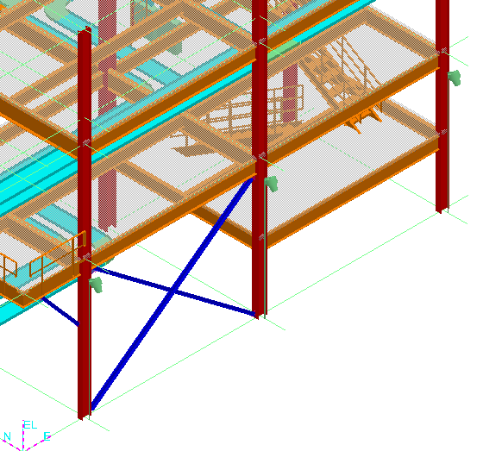

LAB-20: Electrical Equipment Placement with Relationship

- Open a Session file with Imperial Units
- Define Workspace to Display U03 and U03 CS
- Activate Pinpoint
- Select re-position target command
- Set the target at Grid intersection E 8, N 0, EL 44 in U03 CS
- Select place equipment command
- Browse to Equipment\Electrical\Lighting\Electrical Lighting Equipment and select Electricalequip01-E

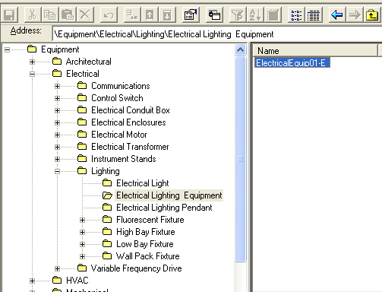

- On properties page, Change the Name to EL-U03-4
- Change the system to A2 > U03 > Equipment
- Ok on the form
- Key in 0 for North and –3 for EL. Select Connect under Relationship options. Select the Outside Surface of column on East side (as shown)
- Select Rotate Command.
- Select X axis (E/W axis) as Rotation axis. Type 45 for Rotation angle

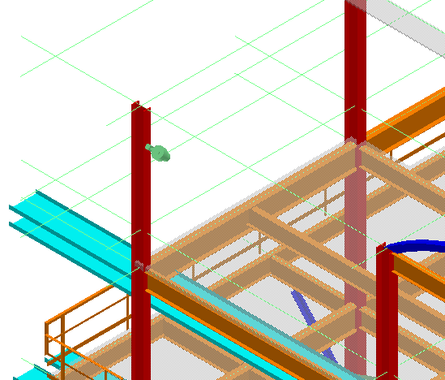

LAB-21: Conduit Routing

- Open a Session file with Imperial Units
- Define Workspace to Display U03 and U03 CS
- Activate Pinpoint
- Change active CS to U03 CS
- Select set target to origin command
- Select Place Equipment command from the vertical toolbar to open the select Equipment Dialog box.
- Locate the electrical enclosures part number BA-106E42309-1E using the tree view. Expand the Equipment Folder and the Electrical Enclosure Folder until you see the part. Select the part and click the OK button.
- Name the equipment, E-300A
- Change the System to A2>U03-> Equipment System
- Switch to Position and orientation category, and make following changes:
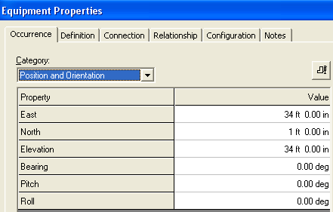
- Select Route Conduit Command
- Select Conduit Port 4 on Electrical Enclosure E-300A as starting location

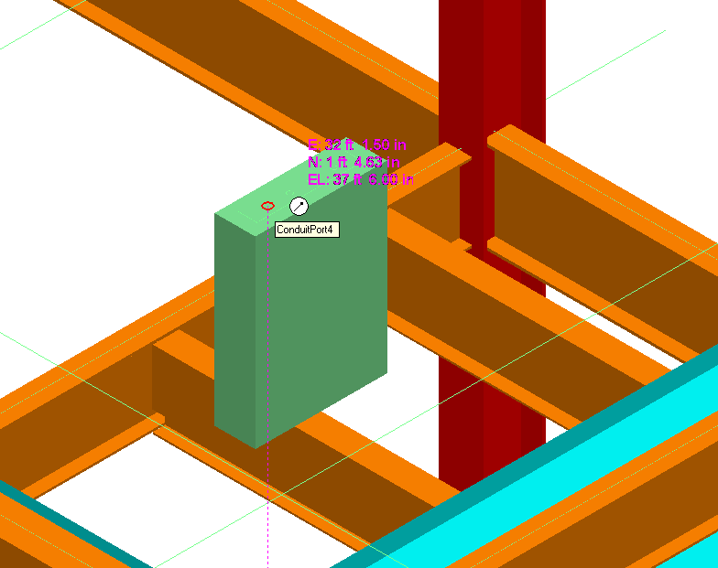

- Set the system toA2, U03, Electrical, Control, conduit
- Set the Spec to CS0
- Switch to Cable fill category
- Set as shown
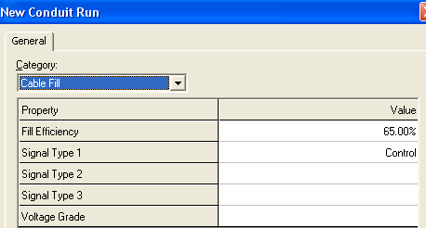
- Route up 3’, Route South 2’, Place a TEE as shown and complete routing as shown in the next page
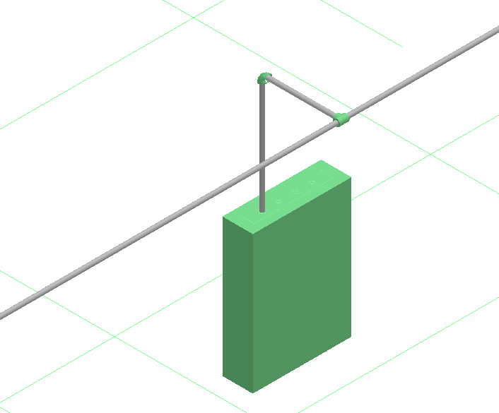

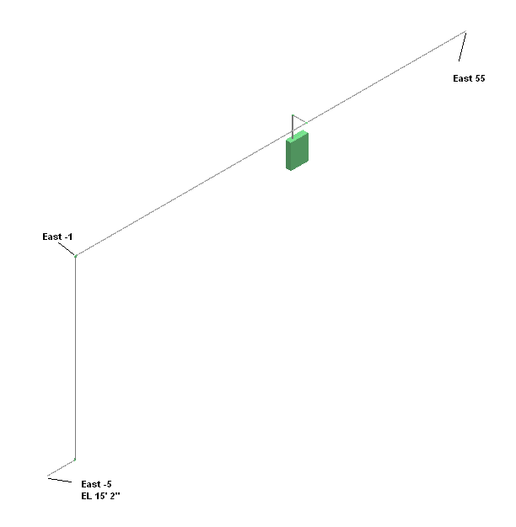

LAB-22: Additional Conduit Routing (Optional)

- Using same spec and size route 3 more conduits as shown in the figures below

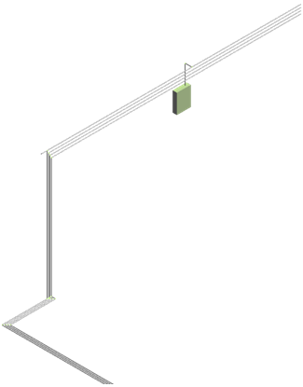

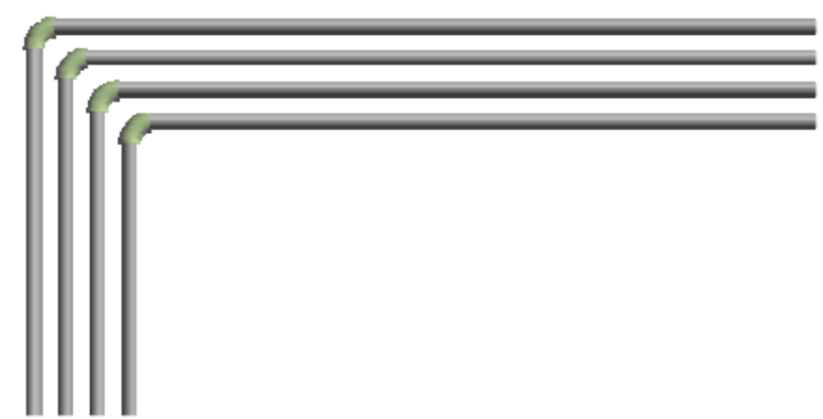

- All offset are 3” (CL – CL)

- Connect all conduit ports of E-300A to conduits. Inset reducers in north-south runs.
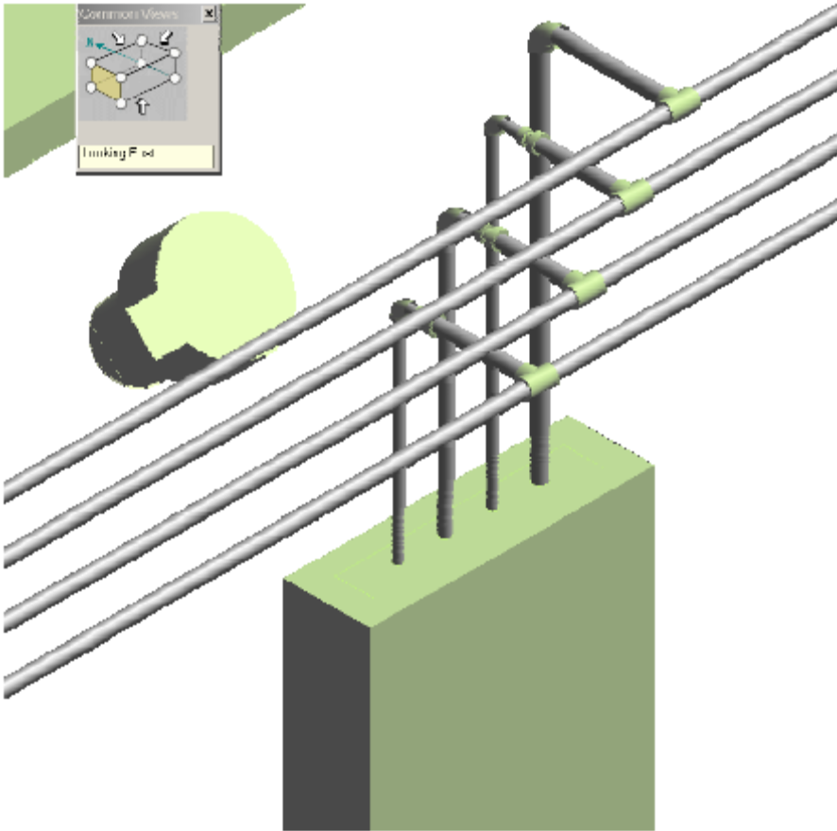

LAB-23: Branching from Elbows Using Blank Spec

- Open a Session file with Imperial Units
- Define Workspace to Display U03 and U03 CS
- Change active CS to U03 CS
- Select set target to origin command
- Set locate filter to cableways
- Hide all cableways except the Low Voltage at elevation 15’ 2” as shown
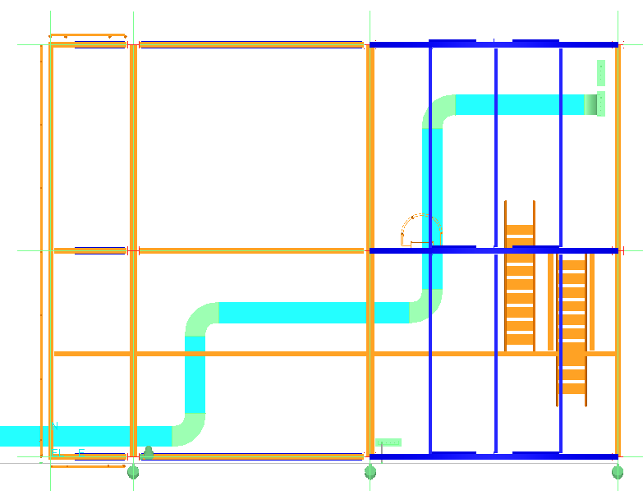
- Select Route Cableway command
- Select mid point of first elbow as starting point as shown below
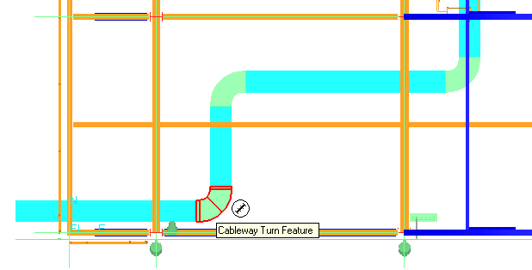
- Make sure system is set to A2, U03, Electrical, Low Voltage, CT
- Select New System and change the Spec to CWS-0
- OK on the form
- Change the size to 6” X 4”
- Route as shown
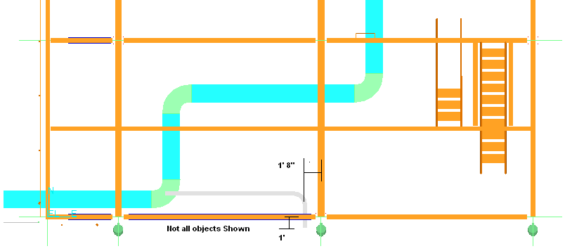

LAB-24: Miter Turns

- Set the locate filter to Cableway Features
- Select the Elbow as shown
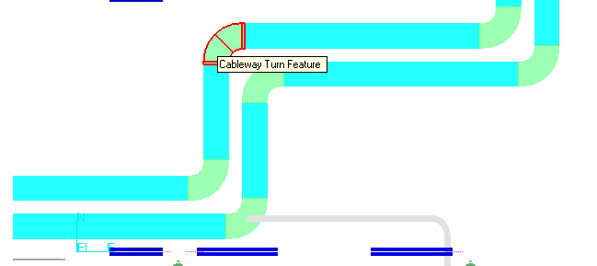
- Under type, change from default to Miter
- Under Miters, enter 1 or other desired number of cuts

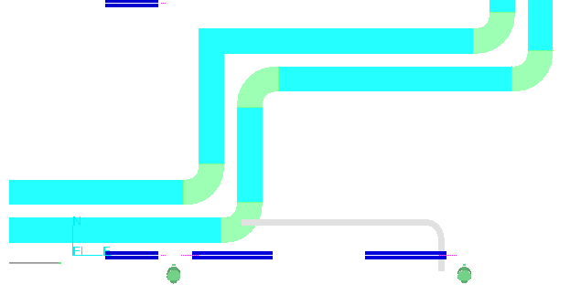

LAB-25: Cableway Splits

- Open a Session file with Imperial Units
- Define Workspace to Display U01 and U01 CS
- Set the locate filter to Cableways
- Select the bottom cableway exiting structure on the North side
- Select Clip by Object command
- Set the locate filter to Cableway Features
- Select Insert Split command
- When prompted for straight features select the tray shown below
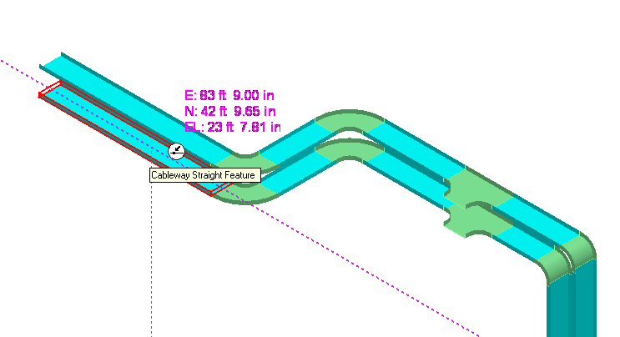
- Set the Split properties as shown
- Finish to apply settings
- Zoom in on the tray and you will be able to see the gap
- Turn off Clip by Object command
- Select Insert Split command
- Select the top straight feature
- Set the Split properties as shown
- Finish
- Zoom in and see multiple splits are placed (best seen in Iso view)
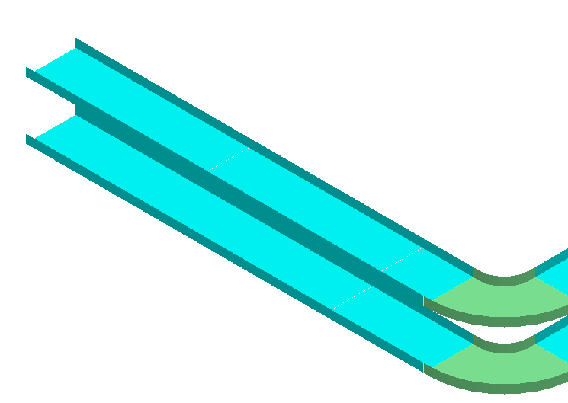

LAB-26: Routing Cable

- Open a Session file with Imperial Units
- Define Workspace to Display U01 and U01 CS
- Select insert cable command
- Select A2, U01, Electrical, Control, CT for system
- Name the Cable CC-001
- Select Control for Signal Type
- Select the Part Number as shown
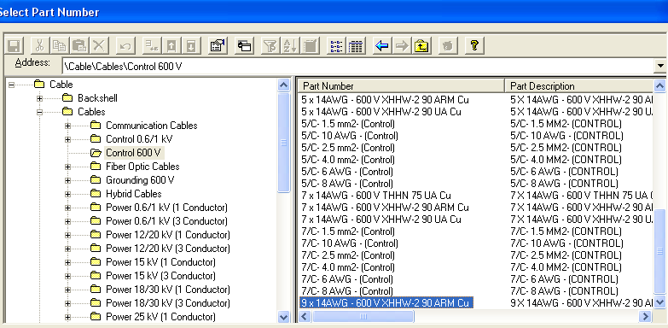

- For originating Device, select A2, U01, Equipment , Electrical Device
- For terminating Device select A2, U01, Equipment , Pump-001
- Hit Apply Button
- Select Insert Next Cable from the top of the form
- Keep the same system
- Name the cable CC-002
- Select Control for Signal Type
- Select the same Part Number used above
- For originating Device, select A2, U01, Equipment , Electrical Device
- For terminating Device select A2, U01, Equipment , Pump-002
- Select OK
- You now have 2 cables running between Electrical Device and Pumps. They’ll be assigned to cableways later
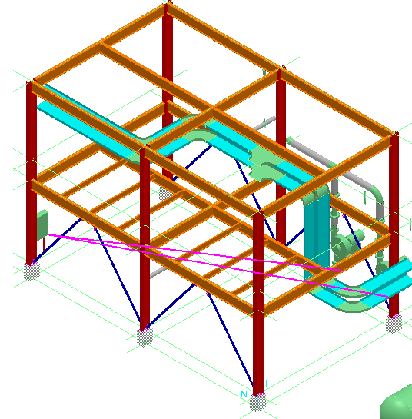

LAB-27: Routing Parallel Cables

- Open a Session file with Imperial Units
- Define Workspace to Display U01 and U01 CS
- Select insert cable command
- Select A2, U01, Electrical, Low Voltage, CT for system
- Name the Cable LV-001
- Type 2 for parallel cables
- Select Power for Signal Type
- Select the part shown
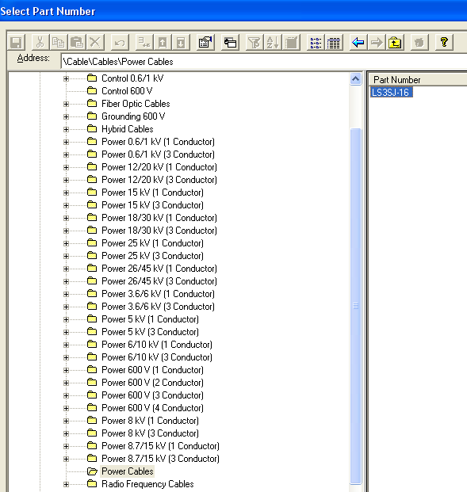
- For originating Device, select A2, U01, Equipment , Electrical Device
- For terminating Device select A2, U01, Equipment , Pump-001
- Hit Apply Button
- Select Insert Next Cable at the top of form
- Keep the same system
- Name the cable LV-002
- Select Power for Signal Type
- Select the same Part Number used above
- For originating Device, select A2, U01, Equipment , Electrical Device
- For terminating Device select A2, U01, Equipment , Pump-002
- Select OK. Notice new parallel cables in Work space explorer error: crashes and LV-001 placed under CTL instead of low voltage
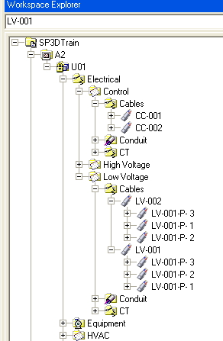

LAB-28: Defining Cable Path (Manual)

- Open a Session file with Imperial Units
- Define Workspace to Display U01 and U01 CS
- Select locate filter to all
- Select cable CC-001 in Work Space explorer
- Go to View, Set view by Cable
- Select Edit Cable Path command from the side bar menu
- Software prompts for cable selection. Green Check on the ribbon bar to accept current selection
- System prompts for position on Cableway for Entry point, Select End feature of Top tray as shown
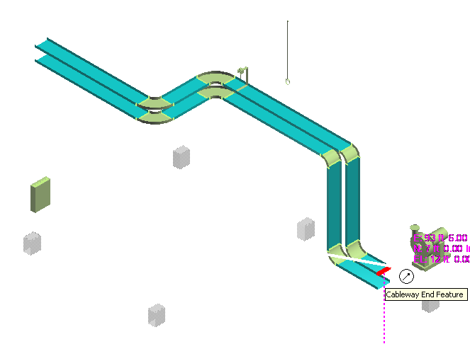
- System shows the cableway path. Make sure cable is going thru the top tray. Green check to accept the path
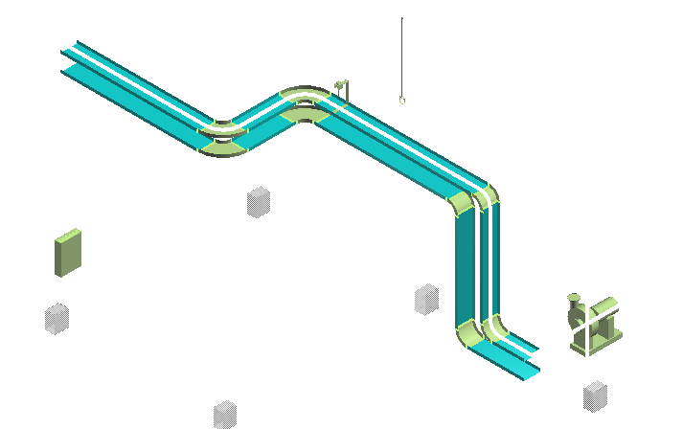
- Select the end feature at the other end of tray as exit point
- Select Finish to complete the cable path. Cable graphics are not always visible, only during editing
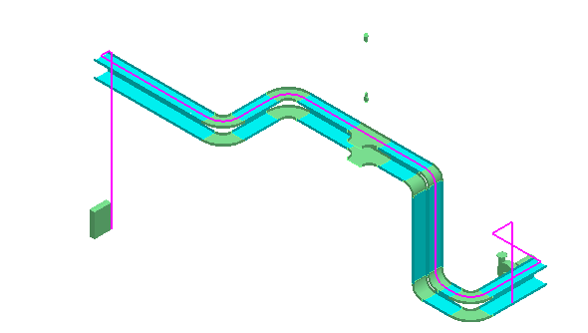
- Select cable CC-001 in WSE and review its properties
- Select View>Clear Clipping. Tools > Show All

LAB-29: Defining Cable Path (Auto Route)

- Open a Session file with Imperial Units
- Define Workspace to Display U01 and U01 CS
- Set locate filter to All
- In WSE select Cables CC-002, LV-001, LV-002
- Select Edit Cable Path command
- Select Auto Route Option Button
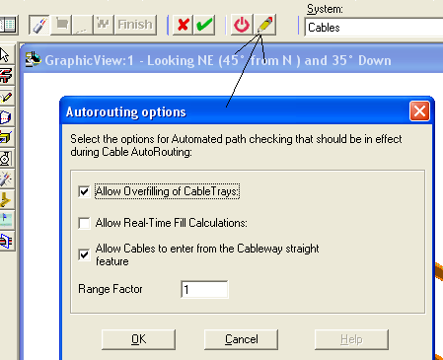
- Set options as shown above and OK on the form
- Select Auto Route option (button before options)
- Software shows the Route for Cables
Note: Software shows control tray for control cables, and Low voltage tray for power cables
- Select Finish

LAB-30: Duct Banks
- Expand the WSE tree and browse to A2, U01, Electrical
- Add a new Electrical System and rename it Duct Bank
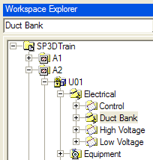
- Start Pinpoint then Route Cableway command
- Specify as starting point E’0, N-20’, EL-3’ in U03 Coordinate System
- Change the info as show in the figure below
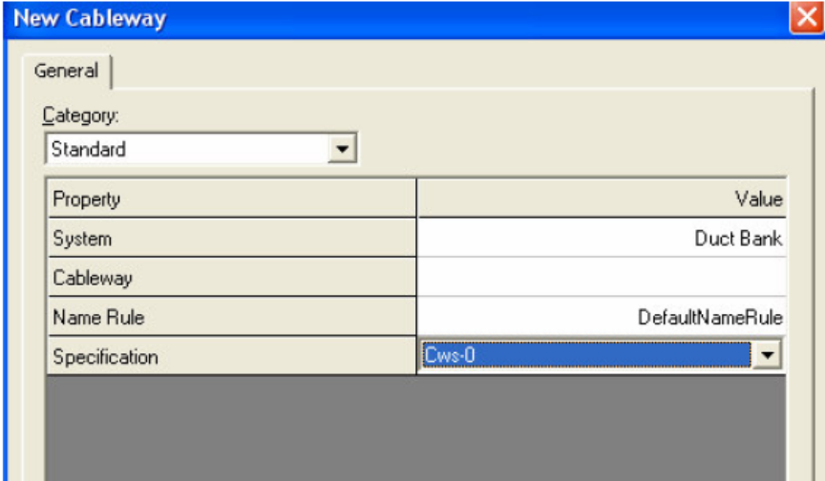
- Select rectangular shape and key in 3’ for width and 2’ for depth
- Route to N 5’
- Take a 2’ X 2’ branch to east 56’ (start the branch at N-4’)
- Insert a 2-ft transition (center-left aligned) to change the size to 2’ X 2’
- Continue north 43’
- Continue east 56’

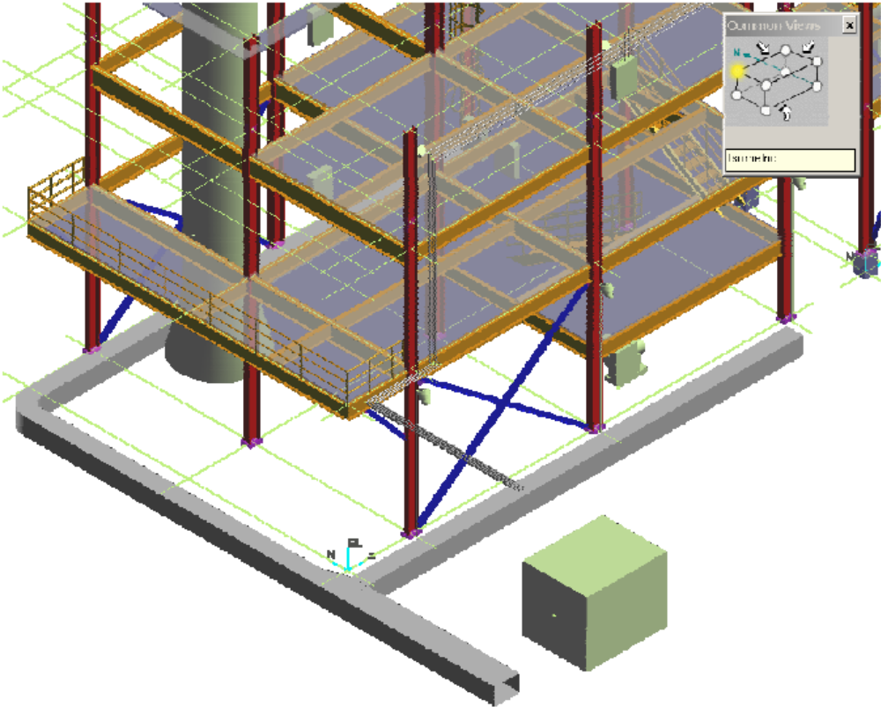

LAB-31: Modify Routing

- Set workspace to UNIT 1 (U01)
- Window in to the cable tray placed during lab 4 (connecting tray to eqp)
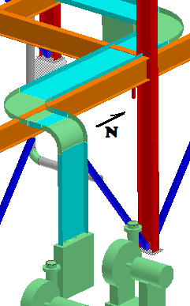
- Select Tools>Options, SmartSketch tab and activate Edges on Solids
- Set the Locate Filter to Cableway Features and select the tray shown that runs North-South
- Select Offset>Set offset reference
- Enter 12in Offset, measured from Surface by Depth and OK
- Set the Plane to N-
- Set SmartSketch List to include the bottom edge of the clashing beam (also in N- direction) in the Stack
- Select the Move To icon from the ribbon bar 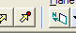
- Slowly move the cursor down on an iso or elevation view until the offset icon and construction graphics appear then click there to accept

LAB-32: Hangers

- Window-in to the trays at the North end of Unit U01
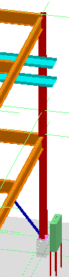
- Switch task to Hangers and Supports
- Select Place Support by Structure command
- Select the two trays at the North end of the structure and accept them by selecting the green check button
- Select the beam directly above them as the supporting structure and green check to accept
- Tentative graphics should appear, click Finish for placement by rule
